Robot Streaming

1. Introduction- This tool allows you to stream the working of an unattended/attended robot to any other machine in same domain network.
2. How to Use- Run the exe file in the robot machine and it will start broadcasting the working of the robot on a specific port and you can view the same from any machine in same network, you just need to browse the URL given below in any browser-

http://<hostname of the robot machine>:<port number>

For example- If the hostname of the robot machine is **uipathrobot** and you have configured the port 8080 to broadcast the streaming then the URL would be

<http://uipathrobot:8080>

Note: You can view the same on your screen once you run the exe

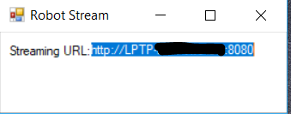

Note: To stream the unattended robot you can use Start Process activity inside your workflow to run this tool and Kill Process activity to stop this once the automation completes.

1. Pre-requisites- The robot machine and the machine where you want to view the stream should be in same network/domain.
2. Configuring the Port Number to Broadcast- Open the UiPathTeam.StreamRobotScreen.exe.config file and specify the port number in the appSettings for the key port and save the same-

